Rainmatter Urban Thesis and Strategy

Objective
This is a document to understand Rainmatter’s Urban thesis and strategy. Readers should be able to understand our thesis, strategy and priorities in how we participate in steering India’s future.

Overview
Rainmatter foundation is a non-profit organization set up by zerodha in 2021 to support India’s growth in a climate friendly pathway. The foundation supports non-profit organisations that are laying the framework of climate friendly growth to redefine how the future of India will emerge uniquely rather than a western model of development. The foundation works with Rainmatter capital which invests in startups working in climate change. We cross leverage each other's capacities to create a hybrid model that enhances the government's ability to create green growth from cities reducing negative externalities.

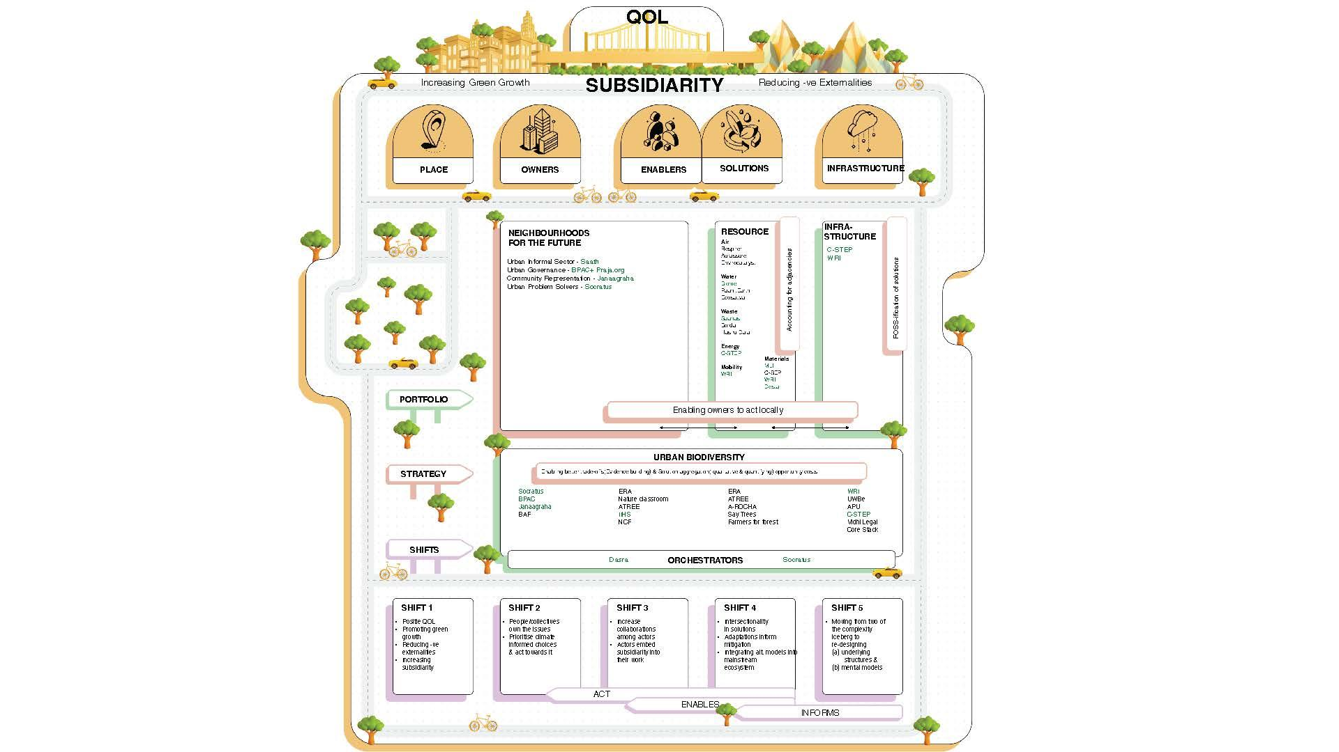
Thesis for urban climate
It is well recognised that Urban India supports the growth objectives and brings prosperity to the nation. But they also cause negative externalities that affect rural livelihoods and natural resources. With more than 7000 census towns and cities that look and behave urban in governance, we believe behaviours by people who are living and working in these towns and cities need to imbibe a place based collective thinking framework.

The foundation strongly believes in place based change that accounts for local contexts. A lot of the market solutions solve for the individual. We support organisations that are able to solve the collective action problems and enable responsible development. We prioritise problems that solve for the “we” rather than just the “I”. The support we provide prioritises pathways from “I” to “we” so we can negate human induced causes of climate change.

Market failures and Collective action problems that the government ends up solving for needs a strong cultural rooting and this comes from place owners. The next wave of growth needs to account for collective ownership and enable place owners to imbibe these into their daily transactions.

Strategies for complex problems
In order to make the thesis happen we have arrived at 4 strategies driven by the gaps we see in innovation and ownership of problems

There are 4 strategies that drive the thesis. We account for all of these when supporting our partners.

Enabling owners of a place to act locally
The government usually acts on behalf of the people living in place to provide common good solutions. It is important in a place based orchestration to capacitate the people who live and consume in the place to be capable of acting locally, to either surface or solve the problems that arise. Reducing information asymmetry and then creating infrastructure items that help people make better trade offs in their decisions is a necessary step.

Solution providers accounting for adjacencies
This needs enablers and solution providers to find other actors in the value chain and the extended ecosystem to establish complementarities. These ecosystem level actors need orchestration by funders and others invested in progress to enable the cross leverages. It is important that we recognise the role of sustainable collaborations beyond convenings so incentives align.

Enabling better tradeoffs including quantifying opportunity costs
Most actors whether in the non-profit or the for-profit domain solve a problem not accounting for unintended consequences to the collective and effects beyond the place. It is important to the actors or the orchestrators to call out the negative externalities of the solution and quantify it so it can be solved by the ecosystem.

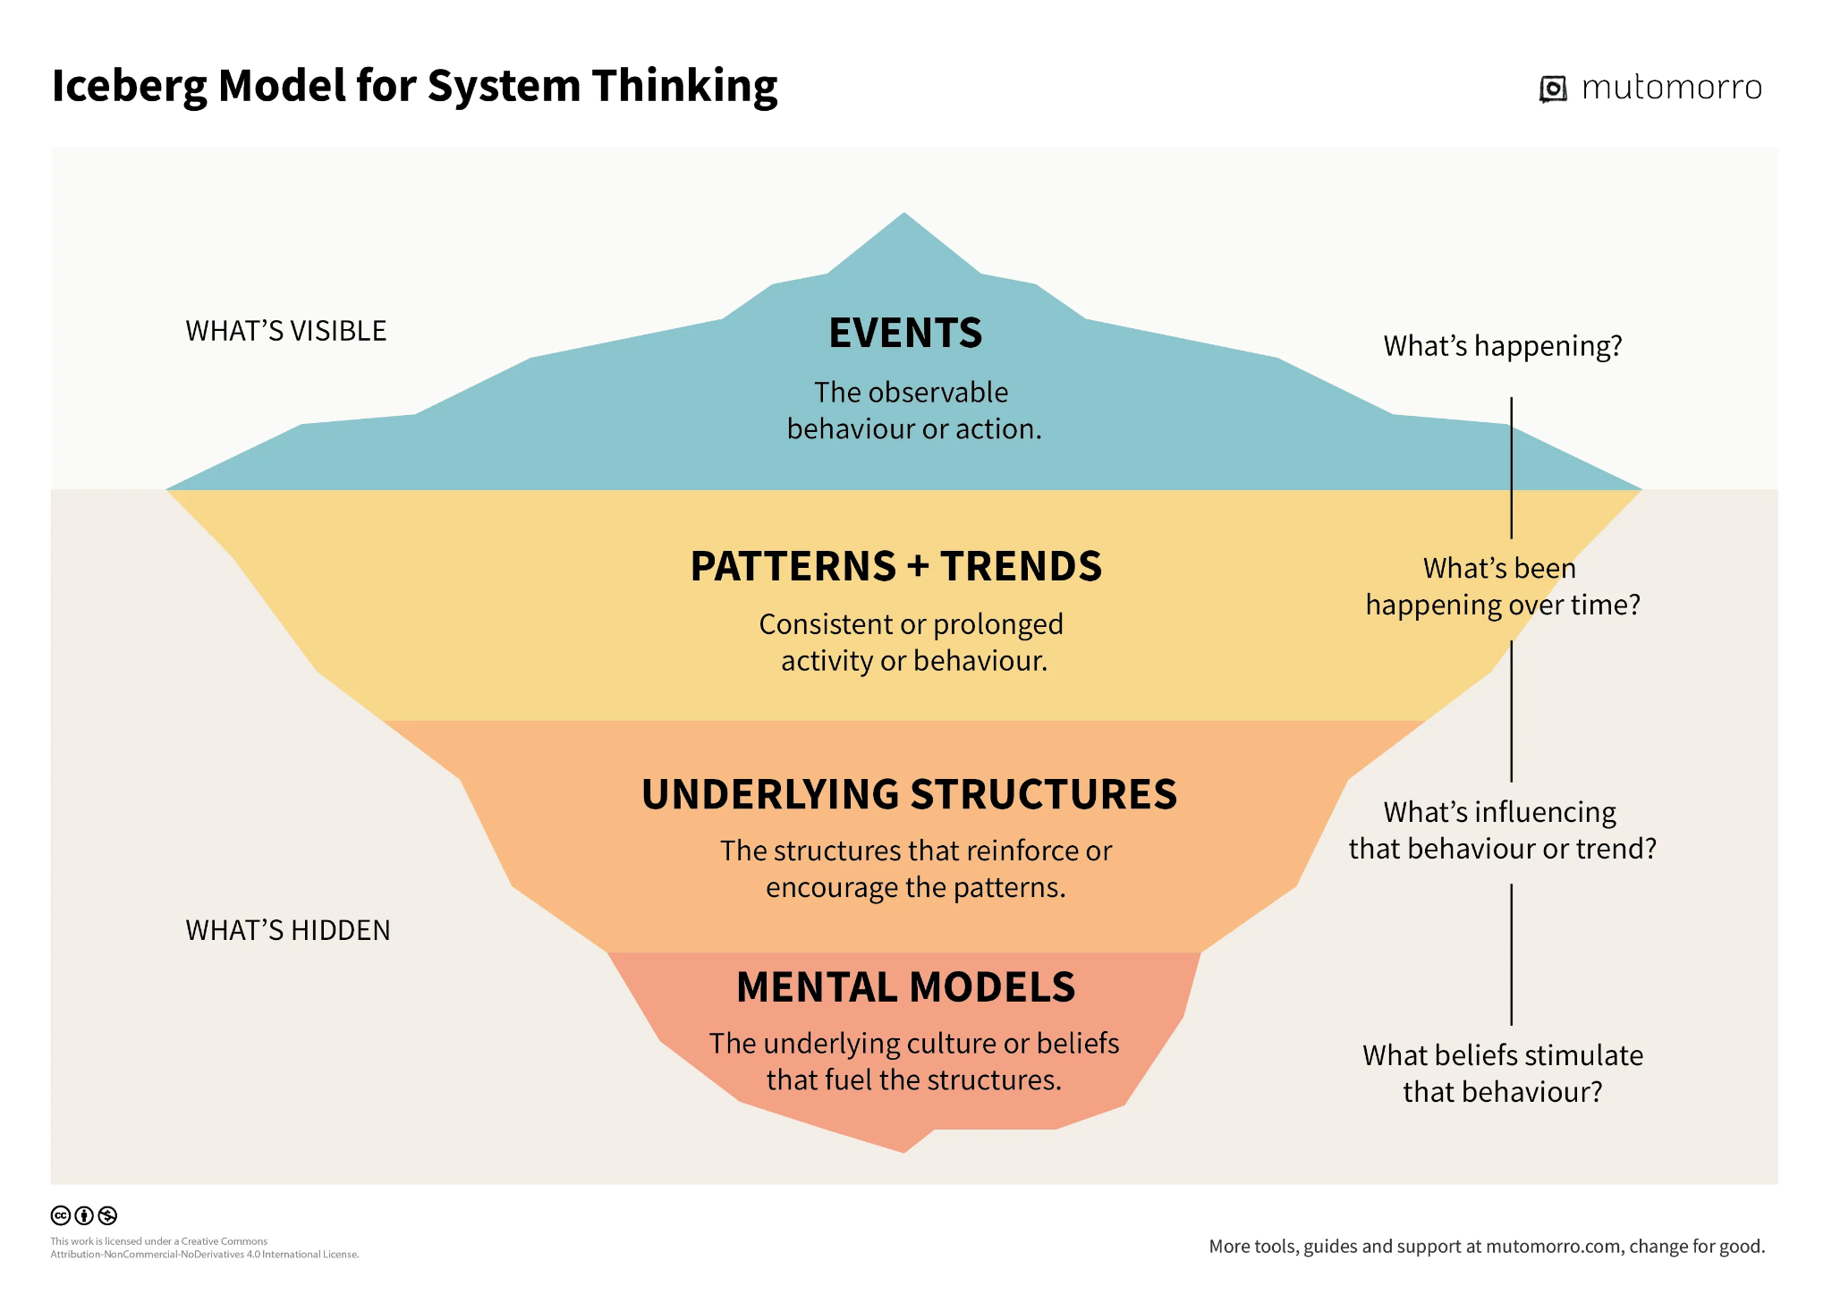
Creating infrastructure that sustains change
In the iceberg model of systems thinking we usually react to events or at best understand patterns by gut feel and repeated occurrences of the event. It is important to think about how mental model shifts and underlying structures can be changed to establish sustainability. The ability of these structures to travel across to the owners

Infrastructure of the future
Infrastructure comes in many forms but their ability to enable actors across places and solutions need to be curated and spread

Process, policies and institutions
Mostly in the realm of the government, these underlying structures usually react to an overton window to make them effective. However some structures need to begin to act earlier to prevent bad tradeoffs from gaining ground. This is a fine balance for the government however non-profits can hold this in place in sandboxed environments to gauge the impacts and inform better tradeoffs. This is where data, research and evidence informs the pathways

Data, research and evidence
The most critical piece of data, research & evidence has been with institutions that are the least incentivised to work with non-government actors. Non-government actors have been creating their own data sets and evidence lacking active involvement of government backed institutions of repute. While that is changing a bit especially with the market players, there is a lot of ground to cover. At Rainmatter Foundation we have been clear to only support those institutions that have the ability to create forward linkages with non-profit and for-profit actors to make all research done before and going forward translatable for consumption and active utilisation.Quantifying tradeoffs, enabling ecological frameworks for action that are practical and implemented on the ground is a conditional way of working that we believe will provide more opportunities for solving problems and leading us to climate friendly prosperity.

Rainmatter Foundation Key Urban Partners
Here are some of the partners we work with

Ecosystem Orchestration
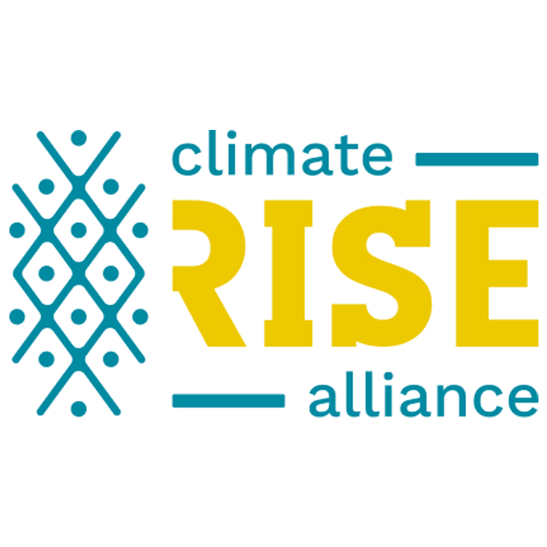
ClimateRISE Alliance is bringing together over 100 civil society organisations, think tanks, intermediary groups and funding organisations. The collaborative platform enables orchestration of actions across partners and stakeholders for climate action in
India


Neighbourhoods of the Future
India’s informal sector employs about 90% of the workforce, contributes around 50% of the non-agricultural GDP and occupies 15-30% of urban land across major Indian cities. Saath is setting up Urban Collaborative for the informal sector as a way to set up a sustainable multi-purpose cooperative (MPC) that can be funded and run by the community to create climate friendly adaptations, mitigations and livelihoods.


Improving the Quality of Life in urban areas needs City Systems thinking. Janagraaha uses the 3 pillars of citizen participation, municipal finance and policy/laws to create structural capacities for solving urban problems.


The proximity project brings climate to the neighbourhood. Socratus is a studio for thinking through and solving wicked problems. They create phygital infrastructure to enable climate as a local conversation through innovative models of engaging with the public via their experience centers.

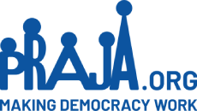
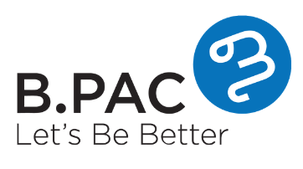
Our government capacity building partners bring all the work done in civil society to help administrators and elected representatives solve public problems. Praja and BPAC envision improving the quality of life for all through simplifying people's lives, creating tools for better governance and making democracy work. Sandboxes that have a potential to solve public problems need to be surfaced to the government agencies and elected representatives so they can make informed decisions.

Infrastructure


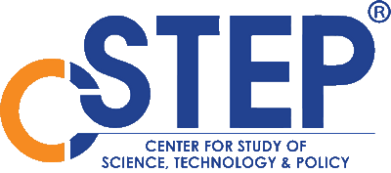
All of is supported by infrastructure anchors who create research, data, knowledge artifacts, synthesise them and make them available to the non-profit and the for-profit sectors who make the change happen on the ground.

